Ideation Phase
Brainstorm & Idea Prioritization Template

Date | 28Febrauary2026
Team ID | LTVIP2026TMIDS36731
Project Name | Heart Disease Analysis
Maximum Marks | 4 Marks

Brainstorm & Idea Prioritization Template:
Brainstorming provides a free and open environment that encourages everyone within a team to participate in the creative thinking process that leads to problem solving. Prioritizing volume over value, out-of-the-box ideas are welcome and built upon, and all participants are encouraged to collaborate, helping each other develop a rich amount of creative solutions.
Use this template in your own brainstorming sessions so your team can unleash their imagination and start shaping concepts even if you're not sitting in the same room.
Step-1: Team Gathering, Collaboration and Select the Problem Statement
Heart disease remains one of the leading causes of mortality worldwide, with its impact continuing to grow due to lifestyle changes, unhealthy dietary habits, and insufficient physical activity. Despite significant advances in medical science, prevention and early detection remain crucial in reducing severe health outcomes. The increasing availability of large-scale healthcare data—covering patient demographics, medical history, lifestyle factors, and clinical indicators— presents an opportunity to better understand the causes and progression of heart disease. However, extracting meaningful insights from such complex datasets requires advanced analytical and visualization tools. In this project, we collaboratively aim to anal heart disease data using Tableau, a powerful data visualization and business intelligence platform. The objective is to transform raw healthcare data into interactive and insightful dashboards that highlight key risk factors and reveal important correlations. These insights can support data-driven decision-making for healthcare professionals, policymakers, and individuals. By leveraging Tableau’s interactive capabilities, the project seeks to uncover hidden trends, compare patient groups, and present compelling data-driven stories that contribute to early detection, preventive care, and increased awareness of heart disease.

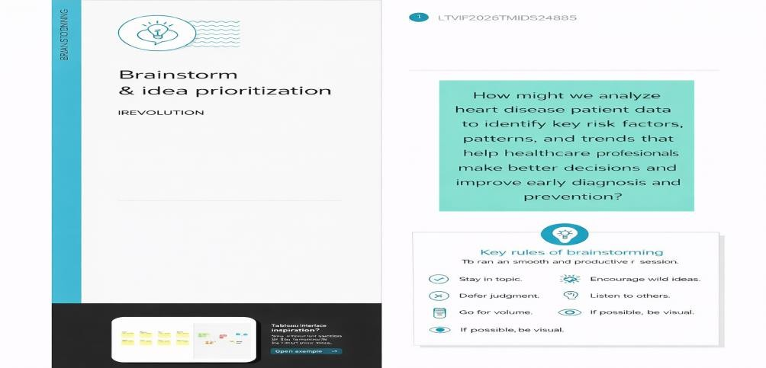

Step-2: Brainstorm, Idea Listing and Grouping
In this step, the team brainstorms ideas related to heart disease analysis. Different factors such as patient demographics, lifestyle habits, and clinical indicators are discussed to understand their impact on heart disease. All ideas are listed without judgment to encourage creativity and collaboration.After brainstorming, the ideas are grouped into meaningful categories such as demographic factors, lifestyle factors, clinical indicators, and visualization ideas. This grouping helps in organizing the analysis and selecting the most important factors for effective visualization using Tableau.

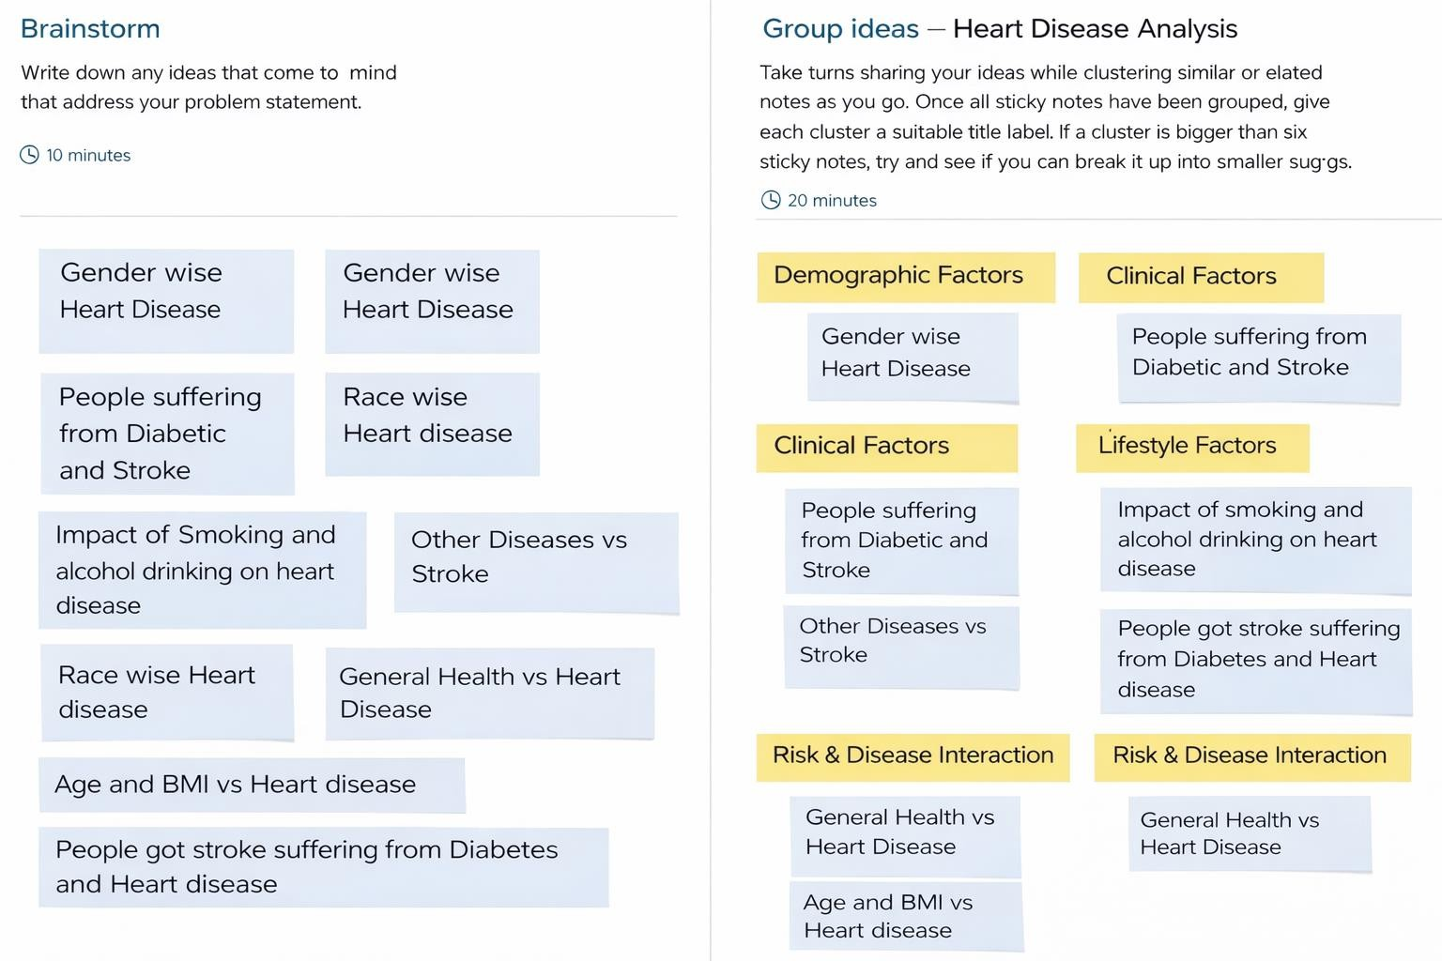

Step-3: Idea Prioritization

